Story Concept #whatever number this is-

**Platform**: Music Video

**Song:** Stereo Hearts ft. Adam Levine by Gym Class Heroes ( <https://www.youtube.com/watch?v=_U0PrwLpb_Q> )

**Synopsis:**

At its core, this story concept revolves around a tale of gently nurtured unrequited/unnoticed love, and one person’s growing desire to express their feelings.

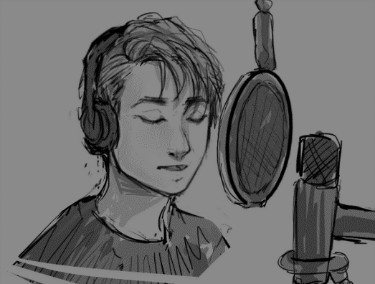The main story takes place within the walls of a warmly-lit recording studio, which a young man sits with headphones pressed to one ear, and a microphone positioned close to his lips. He sings along to the song (Stereo Hearts), as if he himself is recording the track. At some point during the song, he opens his eyes, and his gaze flickers to some place off camera - to a room separated from his by glass pane, the studio control room. Inside several people are busy away at work. One person in particular, a young woman, sits intently listening to his singing with brows furrowed in focus. She meets his gaze and offers him a thumbs up with an excited smile.

Between moments of singing and flickering glances, are flashes of memories of the relationship between these two people, as the recorded love song becomes a hesitantly expressed love letter, from one person to the other.

**Moodboard:** (will link it soon)